WIRELESS POWER TRANSMISSION FOR ELECTRIC VEHICLE

**A-MINI PROJECT-I REPORT**

***Submitted by***

|  |  |
| --- | --- |
| **HARI PRASANNA.G** | **(71812203023)** |
| **JOWIN KERRY.W** | **(71812203033)** |
| **KAVIN KUMAR.M** | **(71812203037)** |

***in partial fulfillment for the award of the degree of***

# BACHELOR OF ENGINEERING

***in***

ELECTRICAL AND ELECTRONICS ENGINEERING

**SRI RAMAKRISHNA ENGINEERING COLLEGE**

**(AN AUTONOMOUS INSTITUTION)**

**COIMBATORE** – **641 022**

# ANNA UNIVERSITY::CHENNAI 600 025

MAY 2024

ANNA UNIVERSITY: CHENNAI 600 025

# BONAFIDE CERTIFICATE

Certified that this Mini Project-I (20EE275) report titled **“WIRELESS POWERTRANSMISSION FOR ELECTRIC VEHICLE SYSTEM ”** is the bonafide work of **“HARI PRASANNA.G,JOWINKERRY.W** and **KAVIN KUMAR.M”** who carried out the Mini Project work under my supervision.

|  |  |
| --- | --- |
| **SIGNATURE** | **SIGNATURE** |
| Dr.S.Allirani  **HEAD OF THE DEPARTMENT***i/c*  Associate Professor,  Electrical and Electronics Engineering, | Dr.R. Krishnakumar  **SUPERVISOR**  Assistant Professor (Sl.G),  Electrical and Electronics Engineering, |
| Sri Ramakrishna Engineering College, Vattamalaipalayam,  N.G.G.O.Colony Post,  Coimbatore – 641022. | Sri Ramakrishna Engineering College, Vattamalaipalayam,  N.G.G.O.Colony Post,  Coimbatore – 641022. |

**Submitted for the Mini Project-I Viva-voce Examination held on**

INTERNAL EXAMINER EXTERNAL EXAMINER

**ACKNOWLEDGEMENT**

We put forth our hearts and souls to thank the ALMIGHTY for being with us through our achievements and success. We would like to express our unfathomable thanks to our esteemed and Honorable Managing Trustee **Sri D.Lakshminarayanaswamy** and Joint Managing Trustee **Sri R.Sundar** for giving us the chance to be a part of this elite team at Sri Ramakrishna Engineering College, Coimbatore.

We would like to express our sincere thanks to our honorable Principal,

**Dr.N.R.Alamelu** for her continuous motivation towards the development of the students.

We take the privilege to thank the Associate Professor and Head of the Department In- Charge of Electrical and Electronics Engineering, **Dr.S.Allirani** for her consistent support and encouragement at every step of our project work.

We would like to express our sincere thanks to our project coordinators, **Mr.V.Gopu, Mrs.R.K.Ragavapriya** and **Mr.C.Praveenkumar**, Assistant Professors/Department of Electrical and Electronics Engineering for their valuable support during the course of development and completion of this project.

We wish to convey our special thanks to our project supervisor, **Dr.R.Krishnakumar** Assistant Professor (Selection Grade), Department of Electrical and Electronics Engineering for his consistent support, timely help and valuable suggestions during the entire period of our project work.

We extend our sincere grtitude to all the teaching and non-teaching staff members of our department who helped us during our project.

We express heartfelt gratitude to our parents for bringing us into this world, inspiring us, standing by us, and providing us with a valuable education that enabled us to successfully completing our project.

## ABSTRACT

Wireless power transmission (WPT) is an emerging technology that has the potential to revolutionize the way electric vehicles (EVs) are charged. WPT eliminates the need for physical contact between the charging station and the EV, making charging more convenient and efficient. This project provides a comprehensive overview of WPT for EVs, including the basic principles, technical challenges, and potential benefits. The project discusses the different types of WPT systems, such as magnetic resonant coupling and inductive power transfer, and their applications in EV charging. It also covers the safety and regulatory issues associated with WPT technology and the measures taken to ensure the safety of users and the environment.

The use of electric vehicles (EVs) is becoming increasingly popular as the world moves towards a greener future. However, the current charging infrastructure for EVs has limitations that must be addressed to encourage wider adoption of EVs. Wireless power transmission (WPT) is an emerging technology that could offer a solution to these limitations by providing a more convenient and efficient way to charge EVs. This project provides an in-depth overview of WPT for EVs, including the basic principles, technical challenges, and potential benefits. The project explores the different types of WPT systems, such as magnetic resonant coupling and inductive power transfer, and their applications in EV charging. It also covers the safety and regulatory issues associated with WPT technology and the measures taken to ensure the safety of users and the environment. One of the main advantages of WPT for EVs is the convenience it offers. With WPT, EVs can be charged without the need for physical contact between the charging station and the vehicle. This eliminates the need for cables, making charging more convenient and efficient. In addition, WPT can offer a seamless charging experience, as EVs could automatically start charging when parked in a designated spot, without the need for drivers to plug in and out. Another potential benefit of WPT for EVs is improved

charging efficiency. Traditional charging methods can suffer from power losses due to heat dissipation, electrical resistance, and other factors. WPT, on the other hand, can achieve higher levels of efficiency, as the charging process is based on the transfer of energy through an electromagnetic field. However, several technical challenges must be addressed before WPT for EVs can become a widely adopted solution. One of the main challenges is optimizing the efficiency of the WPT system. The energy transfer between the charging station and the EV must be efficient to avoid unnecessary power losses and to ensure that charging times are reasonable.

**Key Words:** Wireless power transmission, Resonant coupling, Inductive power transfer

**TABLE OF CONTENT**

|  |  |  |
| --- | --- | --- |
| **CHAPTER** | **TITLE** | **PAGE** |
| **NO.** |  | **NO.** |
|  | **ABSTRACT** | 1 |
| 1 | **INTRODUCTION** | 6 |
|  | 1.1 WIRELESS POWER TRANSMISSION | 6 |
|  | 1.2 AIM OF THE PROJECT | 8 |
|  | 1.3 OBJECTIVE OF THE PROJECT | 9 |
|  | 1.4 LITERATURE SURVEY | 9 |
| 2 | **EXISTING SYSTEM** | 13 |
|  | 2.1 EXISTING METHODOLOGY | 13 |
|  | 2.2 DISADVANTAGES | 14 |
| 3 | **PROPOSED SYSTEM** | 17 |
|  | 3.1 PROPOSED METHODOLOGY | 17 |
|  | 3.2 BLOCK DIAGRAM | 18 |
|  | 3.3 CIRCUIT DIAGRAM | 19 |
| 4 | **HARDWARE DESCRIPTION** | 22 |
|  | 4.1 IRFF40N MOSFET | 22 |
|  | 4.2 IN4007 DIODE | 23 |
|  | 4.3 1000uf 16V CAPACITOR | 24 |
|  | 4.4 LM7805-IC | 25 |
|  | 4.5 BC547 TRANSISTOR | 26 |
|  | 4.6 RESISTOR | 27 |

1. WIRELESS POWER TRANSFER 28
   1. INDUCTIVE COUPLING 28
   2. INDUCTIVE CHARGING 29

INDUCTANCE OF COIL AND COIL 31

1. DESIGN
   1. INTRODUCTION 31
   2. SINGLE LAYER 32
   3. LOSSES IN COIL 33
   4. SKIN EFFECT 34
   5. PARASITIC CAPACITANCE 34
2. RESULTS AND DISCUSSION 36
   1. HARDWARE SETUP 36
3. CONCLUSION AND FUTURE SCOPE 38
   1. CONCLUSION 38
   2. FUTURE SCOPE 39

REFERENCES 40

# LIST OF FIGURES

|  |  |  |
| --- | --- | --- |
| **FIGURE NO.** | **TITLE** | **PAGE NO.** |
| 3.1 | Block diagram representation of proposed system | 18 |
| 3.2 | Circuit diagram of proposed system | 19 |
| 4.1 | Irff40n MOSFET | 23 |
| 4.2 | 1N4007 diode | 23 |
| 4.3 | 1000uf 16V capacitor | 24 |
| 4.4 | Lm7805-IC | 25 |
| 4.5 | BC547 transistor | 26 |
| 5.1 | Inductive coupling | 28 |
| 6.1 | Single layer coil | 31 |
| 7.1 | Hardware setup | 36 |

## CHAPTER 1 INTRODUCTION

* 1. **WIRELESS POWER TRANSMISSION**

Wireless power transmission (WPT) is a technology that has been in development for over a century, with Nikola Tesla being one of the earliest pioneers in this field. However, it is only in recent years that WPT has started to gain more attention and traction, thanks to advances in technology and a growing demand for more efficient and sustainable energy solutions. WPT allows electrical energy to be transferred wireless from a power source to a device or system without the need for physical contact. When an alternating current is applied to the transmitter coil, it generates an electromagnetic field, which induces a current in the receiver coil. This current can then be used to power a device or charge a battery.

The advantages of WPT are numerous. Firstly, it eliminates the need for cables and connectors, making it a more convenient and user-friendly option. This is particularly relevant for devices and systems that require frequent charging or powering, such as smartphones, wearable, and medical devices. Secondly, WPT can offer higher levels of efficiency compared to traditional charging methods, as the charging process is based on the transfer of energy through an electromagnetic field. One of the most promising applications of WPT is in electric vehicle (EV) charging. EVs are becoming increasingly popular as a more sustainable alternative to traditional petrol and diesel-powered vehicles. However, one of the biggest challenges facing the adoption of EVs is the availability and accessibility of charging infrastructure.

Wireless power transmission (WPT) is a revolutionary technology that has the potential to transform the way we power and charge our devices and systems. With WPT, electrical energy can be transferred wireless from a power source to a device or system without the need for physical contact, cables, or connectors. ‘t’ is

only in recent years that WPT has started to gain more attention and traction, thanks

to advances in technology and a growing demand for more efficient and sustainable energy solutions. The basic principle of WPT is the transfer of energy through an electromagnetic field. This is achieved by using two coils, a transmitter coil and a receiver coil, which are tuned to the same frequency. When an alternating current is applied to the transmitter coil, it generates an electromagnetic field, which induces a current in the receiver coil. This current can then be used to power a device or charge a battery. One of the most significant advantages of WPT is its convenience and user-friendliness. With traditional power transfer methods, cables and connectors are required, which can be cumbersome and inconvenient, especially for devices and systems that require frequent charging or powering. WPT eliminates the need for cables and connectors, making it a more convenient and efficient option. This is particularly relevant for smartphones, wearables, and medical devices, where frequent charging is necessary. Another advantage of WPT is its potential to offer higher levels of efficiency compared to traditional charging methods. This is because the charging process is based on the transfer of energy through an electromagnetic field, which can lead to significant energy savings and a reduced environmental impact. Traditional charging methods, such as wired charging, can result in energy losses due to heat generated during the transfer process.

WPT can overcome this issue by eliminating the need for physical contact and reducing the amount of energy lost during the transfer process. WPT also has the potential to enable the creation of new and innovative devices and systems that were not previously possible due to the limitations of wired power transfer. For example, WPT can be used to power wireless sensors and devices in remote or hard-to-reach locations, eliminating the need for costly and complex wiring. One of the most promising applications of WPT is in electric vehicle (EV) charging. With the growing demand for more sustainable and environmentally friendly transportation solutions, In addition, WPT can offer higher levels of efficiency compared to traditional charging methods, as the charging process is based on the

transfer of energy through an electromagnetic field.

Despite the many advantages of WPT, there are several technical and regulatory challenges that must be addressed before it can become a widely adopted technology. One of the biggest challenges is optimizing the efficiency of the WPT system. The efficiency of the system is affected by a number of factors, including the distance between the transmitter and receiver coils, the size and shape of the coils, and the power output of the system. Improving the efficiency of the WPT system is critical to ensure that energy is not wasted during the transfer process. Another challenge is ensuring compatibility with different devices and systems. WPT systems must be designed to work with a range of devices and systems, each with their own unique power requirements and specifications. This requires a deep understanding of the characteristics of each device and system, as well as the ability to adapt the WPT system to meet their specific needs.

## AIM OF THE PROJECT

The aim of the project in wireless power transmission in EVs is to develop a more convenient and efficient way of charging electric vehicles. Traditional charging methods for electric vehicles often require physical contact between the charging station and the vehicle, which can be inconvenient and may limit the accessibility of charging infrastructure.

Wireless power transmission offers a way to overcome these limitations by allowing energy to be transferred wirelessly from the charging station to the vehicle through an electromagnetic field. The goal is to optimize the efficiency and reliability of the wireless power transmission system to make it a viable and widely adopted option for EV charging.

## OBJECTIVES OF THE PROJECT

* To achieve Wireless power transfer via resonant inductive coupling between the transmitting and receiving coils in the near field.
* To provide a convenient, efficient, and safe way to recharge the vehicle's batteries without the need for physical connections, such as cables or wires.

## The benefits of wireless power transmission in EVs include:

* Convenience: EVs can be charged without the need for physical connections, making it more convenient for drivers to recharge their vehicles.
* Efficiency: Wireless power transmission can reduce charging times and increase the range of EVs by allowing them to charge while in motion.
* Safety: Wireless power transmission eliminates the risk of electric shock and reduces the risk of fires caused by damaged charging cables or overheating connections.
* Sustainability: Wireless power transmission can help reduce the environmental impact of EVs by enabling renewable energy sources, such as solar or wind power, to be used for charging.

## LITERATURE SURVEY

**"Electric Vehicle Charging Technologies and Standards: by Anil K. Rajvanshi, 2019.** It provides a comprehensive overview of various electric vehicle (EV) charging technologies and standards. It discusses Level 1, Level 2, and DC fast charging technologies and standards, and their pros and cons. The paper also covers the topics of charging infrastructure deployment and smart charging. Level 1 charging refers to charging an EV using a standard household outlet, while Level 2 charging uses a dedicated EV charging station and can charge an EV faster than Level 1 charging. DC fast charging, on the other hand,

uses direct current to charge an EV's battery at a much faster rate than Level 2 charging. The paper also discusses the deployment strategies of EV charging infrastructure, including public and private charging stations, and the challenges associated with their deployment, such as cost and interoperability. Finally, the paper covers the topic of smart charging, which involves the use of communication and control technologies to optimize the charging process and reduce the strain on the power grid.

**"Charging Infrastructure for Electric Vehicles: A Review of Current Status and Future Trends" by Long Chen, 2020.** It provides an overview of the current status and future trends of electric vehicle (EV) charging infrastructure. The paper discusses the different types of EV charging stations, including Level 1, Level 2, and DC fast charging stations. Level 1 charging stations use a standard household outlet to charge an EV, while Level 2 charging stations use a dedicated EV charging station and can charge an EV faster than Level 1 charging. DC fast charging stations, on the other hand, use direct current to charge an EV's battery at a much faster rate than Level 2 charging stations. The paper also covers the deployment strategies of EV charging infrastructure, such as public and private charging stations, and the challenges associated with their implementation. One of the main challenges is cost, as the installation and operation of charging stations can be expensive. Another challenge is interoperability, as there are different types of charging connectors and protocols used by different EV manufacturers and charging station operators. The authors also examine potential solutions to these challenges, such as government policies to promote EV adoption and support the deployment of charging infrastructure, public-private partnerships to share the cost and responsibility of building charging infrastructure, and the use of smart charging technologies to optimize the charging process and reduce the strain on the power grid.

**"Wireless Charging Technologies for Electric Vehicles: A Comprehensive Review" by Fengwei Tan, 2020**. is a review that provides a comprehensive overview of wireless charging technologies for electric vehicles (EVs). The paper covers the various types of wireless charging systems, such as magnetic resonance, inductive power transfer, and capacitive coupling, and their applications in different types of EVs, such as plug-in hybrid electric vehicles (PHEVs) and battery electric vehicles (BEVs). The paper also discusses power transfer efficiency, which is one of the key factors affecting the performance and practicality of wireless charging systems. The authors examine the factors that affect power transfer efficiency, such as the distance between the charging pad and the EV, the orientation of the EV, and the quality of the charging pad and the receiving coil. The paper also covers system design considerations, such as the design of the charging pad and the receiving coil, the selection of operating frequency, and the use of control algorithms to optimize the charging process. In addition, the paper discusses regulatory issues associated with wireless charging, such as electromagnetic compatibility, safety, and interoperability. The authors examine the standards and regulations that govern wireless charging systems, such as SAE J2954, which is a standard for wireless power transfer between EVs and charging infrastructure. Finally, the paper explores the future trends in wireless charging technologies for EVs, such as the integration of wireless charging into roads and parking lots, which can enable continuous charging while the EV is in motion or parked, and the development of dynamic wireless charging systems, which can enable EVs to charge wirelessly while on the move. Overall, this paper provides a comprehensive review of wireless charging technologies for EVs, covering various aspects of the technology, from system design and power transfer efficiency to regulatory issues and future trends.

**"Smart Charging for Electric Vehicles: A Review of the Technical and Business Issues" by Jonn Axsen, 2020.** It covers the technical and

business aspects of smart charging for electric vehicles (EVs). The paper first provides an overview of the concept of smart charging, which involves using advanced technologies and algorithms to manage and optimize the charging process for EVs. The technical aspects of smart charging are discussed in detail, including communication protocols, data management, and control algorithms. The authors also describe the different types of smart charging systems, such as demand response, vehicle-to-grid (V2G), and energy storage systems. In addition to the technical aspects, the paper also covers the business and policy issues related to smart charging. Pricing strategies, revenue models, and regulatory frameworks are discussed in detail, as well as the challenges and opportunities associated with the commercialization of smart charging systems. The authors provide insights into the potential benefits of smart charging, including improved grid stability and reduced electricity costs, as well as the potential barriers to adoption, such as lack of interoperability and high upfront costs. Finally, the paper presents case studies of smart charging implementation in different regions and countries, such as the Netherlands, California, and Japan. The authors discuss the outcomes and lessons learned from these case studies, highlighting the importance of collaboration between stakeholders and the need for clear policy frameworks to facilitate the deployment of smart charging infrastructure. Overall, this review paper provides a comprehensive and insightful overview of smart charging for electric vehicles, highlighting the technical, business, and policy issues associated with its implementation.

## CHAPTER 2 EXISTING SYSYTEM

* 1. **EXISTING METHODOLOGY**

The existing system for electric vehicle (EV) charging is comprised of several components, including charging infrastructure, charging stations, charging networks, and pricing models. Let's look at each of these components in detail: **Charging Infrastructure:** The charging infrastructure includes the physical infrastructure required for EV charging, such as power supply, electrical wiring, and charging equipment. This infrastructure can be installed at different locations, including homes, workplaces, public spaces, and along highways. The charging infrastructure must comply with relevant safety standards and regulations, and it must be able to provide the required power to charge the EV's battery.

**Charging Stations:** Charging stations are the physical units that provide power to charge the EV's battery. There are several types of charging stations, including Level 1, Level 2, DC fast charging, and wireless charging. Level 1 charging stations are the slowest, providing 2-5 miles of range per hour of charging. Level 2 charging stations provide faster charging, offering 10-20 miles of range per hour of charging. DC fast charging stations provide the fastest charging, delivering up to 80% charge in as little as 20-30 minutes. Wireless charging stations use magnetic induction or resonant charging technology to transfer power to the EV's battery without the need for cables.

**Charging Networks:** Charging networks are the networks of charging stations that are owned and operated by third-party service providers. These providers offer subscription-based charging plans, mobile apps for locating charging stations, and customer support services. The charging networks provide an essential service to EV owners who need to charge their vehicles on the go, and they help to expand the charging infrastructure beyond individual homes and workplaces.

**Pricing Models:** There are several pricing models for EV charging, including flat

rate, time-of-use, and per-kWh pricing. Flat rate pricing charges a fixed amount per charging session, regardless of the charging speed or the amount of energy used. Time-of-use pricing charges different rates depending on the time of day, with lower rates during off-peak hours. Per-kWh pricing charges a fixed rate per unit of energy consumed, regardless of the charging speed or the time of day. Overall, the existing system for EV charging is rapidly evolving, with new technologies and infrastructure being developed to meet the growing demand for electric vehicles. The system is complex, with different types of charging stations, charging networks, and pricing models, but it provides a convenient and cost-effective way to charge EVs.

## DISADVANTAGES

* + - **Charging Time:** EV charging times can vary depending on the type of charger and the size of the battery. Even with the fastest DC fast charging stations, it can take up to 30 minutes to charge an EV's battery to 80%, which is much longer than refueling a gas-powered vehicle. While some EV owners may be willing to wait for this length of time, others may find it inconvenient, especially for long-distance travel. Additionally, charging times can vary depending on the number of cars using the charging station at the same time, which can lead to longer wait times.
    - **Range Anxiety:** Range anxiety is a significant disadvantage of the existing EV charging system, as EV owners may be hesitant to travel long distances or in areas with limited charging infrastructure. This can reduce the practicality and convenience of EVs, which can deter potential buyers. While the charging infrastructure is growing rapidly, more charging stations are needed in remote areas and along highways to alleviate range anxiety. Additionally, the range of EVs can be affected by factors such as weather conditions and driving habits, which can exacerbate range anxiety.
    - **Cost:** The cost of EVs and charging infrastructure can be a significant barrier

to adoption, especially for lower-income households. While the cost of EVs is decreasing, they are still more expensive than gas-powered vehicles. Additionally, installing home charging stations can be costly, and the cost of DC fast charging stations can be high for public charging providers. This can limit the accessibility of EVs to those with higher incomes and slow down the transition to an all-electric transportation system. However, some governments and organizations are offering incentives to encourage EV adoption and address cost barriers.

* + - **Grid Capacity:** The existing electricity grid may not have the capacity to handle the increased demand for electricity from EV charging. As more EVs are adopted, the demand for electricity will increase, which may strain the grid and cause power outages. This can be a significant challenge, especially in areas with older infrastructure. Smart grid technology can help manage the demand for electricity and ensure a reliable and efficient supply, but it requires significant investment and implementation. Additionally, the increased demand for electricity can lead to higher electricity prices, which can affect EV owners' cost savings.
    - **Environmental Impact:** While EVs are much cleaner than gas-powered vehicles, the electricity used to charge them may still come from non-renewable sources such as coal or natural gas. This can negate some of the environmental benefits of EVs. Additionally, the production of EV batteries can have a significant environmental impact, including the extraction of raw materials and the disposal of used batteries. However, as the proportion of renewable energy sources in the grid increases, the environmental impact of EV charging will decrease. Additionally, advancements in battery technology and recycling can reduce the environmental impact of EV batteries. Overall, while the existing methodology for EV charging has many advantages, these disadvantages need to be addressed to ensure a smooth transition to an all-electric transportation system. This requires significant investment in charging infrastructure, smart

grid technology, and renewable energy sources, as well as policies and incentives to encourage EV adoption and address cost barriers. Additionally, addressing range anxiety and reducing charging times can improve the practicality and convenience of EVs, which can increase their adoption.

## CHAPTER 3 PROPOSED SYSTEM

* 1. **PROPOSED METHODOLOGY**

The concept of wireless power transmission for electric vehicles aims to provide a convenient and efficient way to recharge electric vehicles without the need for a physical plug-in connection. The main goal is to design a wireless charging system that can be used by all types of electric vehicles, including buses, cars, and light trains. This technology would eliminate the need for drivers to find and connect to a charging station, reducing the hassle and time required to charge the vehicle. The system works by using a technology called inductive power transfer (IPT), which involves using an electromagnetic field to transfer energy wirelessly from a charging pad on the ground to a receiver on the vehicle.

The receiver is typically installed on the underside of the vehicle, where it can be positioned close to the charging pad during the charging process. The design of the wireless charging system involves several components, including the charging pad, the receiver, and the control system. The charging pad is typically installed on the ground, and it consists of a set of coils that generate an electromagnetic field. The receiver is installed on the vehicle, and it also consists of a set of coils that can pick up the electromagnetic field and convert it into electrical energy to charge the battery. The control system is responsible for managing the charging process, ensuring that the receiver is properly aligned with the charging pad, and monitoring the power flow to prevent overcharging or overheating of the battery.

The control system can also communicate with the vehicle's onboard computer to optimize the charging process and minimize the charging time. Overall, the concept of wireless power transmission for electric vehicles offers several advantages, including convenience, reduced charging time, and improved safety. However, there are also some challenges associated with this technology,

such as the need for standardized charging protocols, compatibility with different types of vehicles, and the cost of installing the charging station

Additionally, researchers are exploring new materials and designs for the charging pads and receivers to improve efficiency and reduce costs. They are also investigating the use of higher power levels to reduce charging times, as well as the integration of wireless charging into existing infrastructure, such as roadways and parking lots. Another challenge is the limited range of wireless charging systems, which requires vehicles to be parked directly over the charging pad to receive power. To address this, researchers are exploring the use of dynamic wireless charging, which involves installing charging pads along the road to allow vehicles to charge while driving.

## BLOCK DIAGRAM

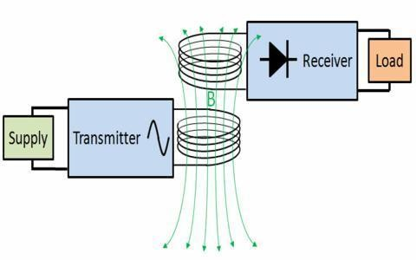

**Fig 3.1 Block diagram representation of proposed system**

## CIRCUIT DIAGRAM

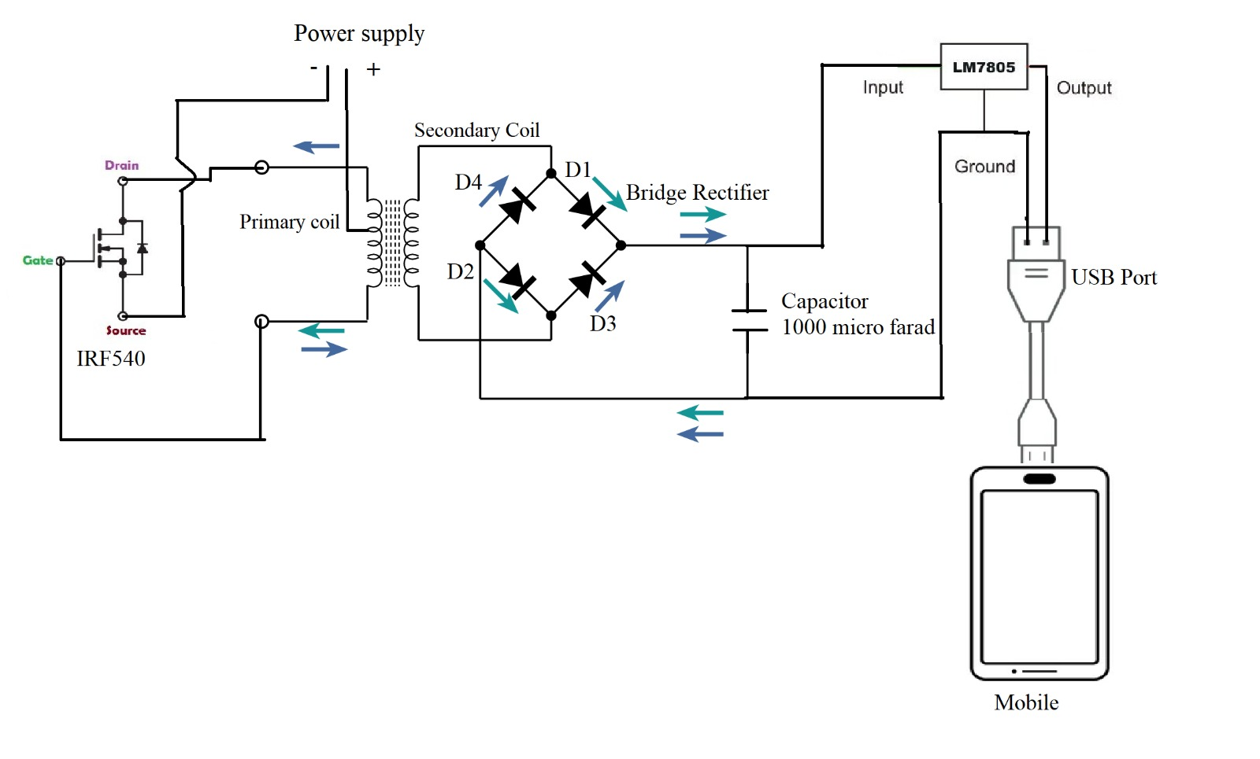

**Fig 3.2 Circuit of proposed system**

The methodology for designing a wireless power transmission system for electric vehicles involves several steps. The first step is to design the charging pad that will generate the electromagnetic field. This involves selecting the appropriate materials, such as copper or aluminum, and determining the size and shape of the coil. The size and shape of the charging pad will depend on the size and type of vehicles that will be charged, as well as the power requirements for each vehicle. The next step is to select the appropriate frequency for the electromagnetic field. The frequency will depend on the size and shape of the charging pad, as well as the distance between the charging pad and the receiver on the vehicle. The frequency should be selected to ensure that the electromagnetic field is strong enough to transfer energy efficiently but not so strong that it poses a safety risk to people or other objects in the area. The receiver on the vehicle must be designed to pick up the electromagnetic field and convert it into electrical energy.

This involves selecting the appropriate materials for the coils,

determining the size and shape of the coils, and ensuring that the receiver is properly aligned with the charging pad. The receiver must also be designed to withstand the elements and the stresses of everyday use. The control system is responsible for managing the charging process and ensuring that the battery is not overcharged or overheated. This involves developing algorithms to monitor the power flow and adjust the charging rate as needed. The control system must also be able to communicate with the vehicle's onboard computer to optimize the charging process and minimize the charging time. Once the system is designed and built, it must be tested and validated to ensure that it is safe and effective. This involves testing the system under various conditions, such as different weather conditions and different types of vehicles. The testing process should also include safety tests to ensure that the system does not pose a risk to people or other objects in the area. Once the system has been validated, it can be deployed in various locations, such as parking lots, highways, and other public areas. The deployment process will involve installing the charging pads and receivers, as well as establishing communication protocols and safety guidelines. The system should also be regularly maintained to ensure that it continues to operate safely and effectively.

## There are several challenges associated with implementing a wireless power transmission system for electric vehicles:

One of the main challenges of implementing a wireless power transmission system for electric vehicles is the cost. The cost of the charging infrastructure can be high, including the cost of the charging pads, receivers, and control systems. The installation of a large number of charging stations can be costly, which may limit the widespread adoption of the technology. Another challenge is the efficiency of wireless charging systems. Wireless charging can be less efficient than plug-in charging systems, which can result in longer charging times and reduced range for electric vehicles. In order to address this issue, researchers and engineers are exploring ways to improve the efficiency

of wireless charging systems, such as by increasing the power transfer efficiency and optimizing the alignment between the charging pad and the receiver on the vehicle. Standardization is another challenge for wireless charging systems. Standardization of the charging protocols and hardware is critical to ensure interoperability between different types of vehicles and charging stations. Without standardization, there may be compatibility issues between different systems, which could limit the widespread adoption of the technology.

Standardization efforts are currently underway, including the development of international standards by organizations such as the International Electro technical Commission (IEC). Safety is also a concern for wireless charging systems. Safety measures must be taken to prevent electrical shocks, fire hazards, and other safety risks for both the user and the vehicle. The design and installation of the charging infrastructure must meet safety standards and regulations to ensure safe operation. Finally, range limitations are a challenge for wireless charging systems. The range between the charging pad and the receiver on the vehicle is currently limited, which means that vehicles must be parked directly over the charging pad to receive a charge. This can be inconvenient for drivers and limit the locations where charging stations can be installed. Researchers and engineers are exploring ways to extend the range of wireless charging systems, such as by using higher frequency electromagnetic fields or developing new technologies such as magnetic resonance coupling.

## CHAPTER 4 HARDWARE DESCRIPTION

* 1. **IRFF40N MOSFET**

IRF540N is an N-channel power MOSFET designed for high voltage applications, such as power supplies, motor controls, and other power switching applications. It is manufactured by Infineon Technologies, a German semiconductor company. The IRF540N has a maximum drain-source voltage of 100 volts and a continuous drain current of 33 amps. It has a low on-resistance of

0.044 ohms, which means that it can handle high power levels with low power dissipation. The MOSFET has a three-terminal device structure, consisting of the source, gate, and drain terminals. The gate terminal controls the flow of current between the source and drain terminals by modulating the channel resistance. The device is turned on when a positive voltage is applied to the gate terminal relative to the source terminal. The device is turned off when the voltage applied to the gate terminal is reduced to zero. The IRF540N is housed in a TO-220 package, which provides a high level of thermal conductivity to dissipate heat generated during operation. The package has three leads, with the centre lead connected to the drain terminal and the two outer leads connected to the source and gate terminals. The MOSFET has several features that make it suitable for high voltage applications. It has a fast-switching speed, which enables it to switch high currents quickly. It also has a low gate charge, which reduces the amount of power required to drive the gate terminal. The MOSFET has a wide operating temperature range, which makes it suitable for use in a variety of environments. Overall, the IRF540N is a versatile and reliable MOSFET that is well-suited for a variety of high voltage applications. Its low on-resistance, fast switching speed, and low gate charge make it an excellent choice for power supplies, motor controls, and other power switching applications.

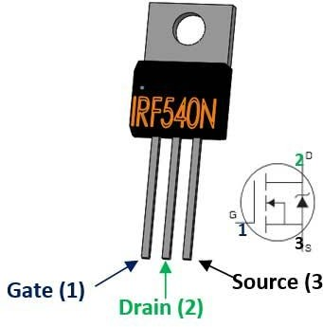

**Fig 4.1 IRFF40N**

## 1N4007 DIODE

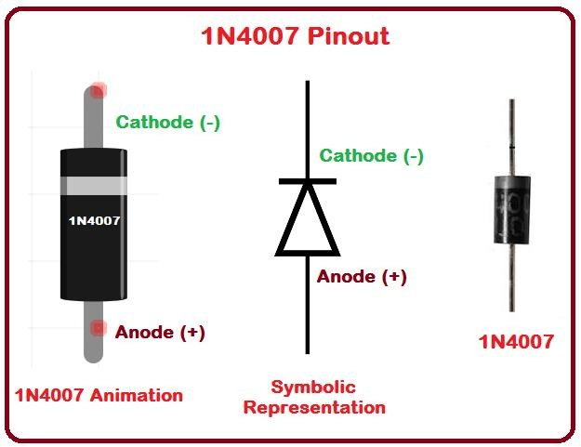

**Fig 4.2 1N4007 DIODE**

The 1N4007 is a type of rectifier diode widely used in electronic circuits. It is a member of the 1N400x series of rectifier diodes, which are designed to handle high voltage and current loads. The 1N4007 is the highest voltage rating diode in the series, with a maximum repetitive reverse voltage of 1000 volts and a maximum forward current of 1 ampere. The 1N4007 is a standard silicon rectifier diode with a

forward voltage drop of approximately 0.7 volts at a forward current of 1 ampere. It has a reverse recovery time of 30 microseconds, which means that it can switch from forward conduction to reverse blocking quickly. The diode has a maximum junction temperature of 150°C, which must be taken into account when designing circuits that use it. The 1N4007 diode is available in a variety of packages, including axial lead through-hole, surface mount, and chassis mount packages. It is used in a wide range of applications, such as rectification, freewheeling, and clamping circuits. It is commonly used in power supplies, battery chargers, and electronic inverters. The 1N4007 diode has several important features that make it suitable for a wide range of applications. It has a high voltage rating, which makes it suitable for use in circuits that require a high voltage rectification. It also has a low forward voltage drop, which reduces the amount of power dissipated in the diode and improves overall efficiency. Additionally, it has a fast reverse recovery time, which makes it suitable for use in circuits that require fast switching. Overall, the 1N4007 is a widely used rectifier diode with a high voltage rating, low forward voltage drop, and fast reverse recovery time. It is a reliable and cost-effective component that is essential in many electronic circuits.

## 1000uf 16V CAPACITOR

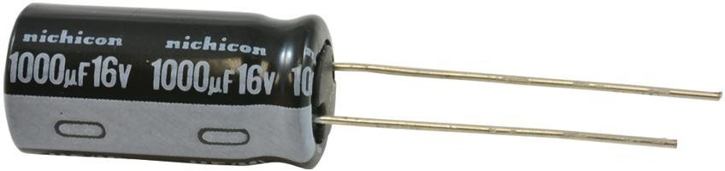

**Fig 4.3 1000uf 16V CAPACITOR**

A 1000uF 16V capacitor is an electrolytic capacitor with a capacitance of 1000 micro farads and a maximum voltage rating of 16 volts. It is commonly used in electronic circuits to filter noise, stabilize voltage, and store and discharge

electrical energy. The 1000uF capacitance value means that the capacitor can store up to 1000 micro coulombs of electric charge per volt of applied voltage. This high capacitance value allows the capacitor to store a large amount of charge, making it useful for smoothing out voltage fluctuations or providing a temporary power source during short power interruptions. The 16V voltage rating indicates the maximum voltage that the capacitor can withstand without breaking down or leaking. It is important to choose a capacitor with a voltage rating that is higher than the maximum voltage in the circuit to ensure safe and reliable operation. The 1000uF 16V capacitor is typically cylindrical in shape, with leads that can be soldered to a circuit board. The anode (positive) lead is typically longer than the cathode (negative) lead, and the capacitor may be marked with a stripe or other indicator to denote the polarity. Electrolytic capacitors like the 1000uF 16V capacitor have a liquid electrolyte inside that helps conduct electricity between the two plates. This makes them more efficient at storing charge than other types of capacitors, but they can also be more sensitive to temperature and voltage fluctuations. Overall, the 1000uF 16V capacitor is a common and useful component in electronic circuits, providing energy storage and voltage regulation capabilities.

## 4.4 LM7805 - IC

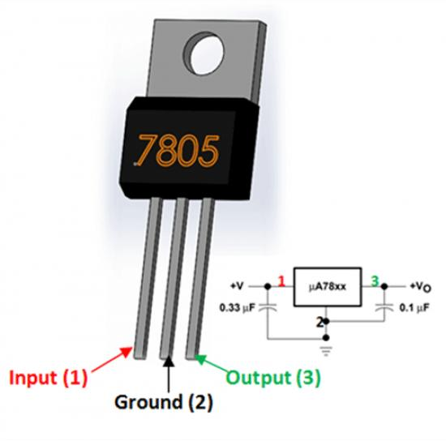

**Fig 4.4 LM7805 - IC**

LM7805 is a three-terminal linear voltage regulator that is commonly used in electronic circuits to regulate a stable output voltage. The LM7805 is part of the

LM78xx series, which includes other regulators that provide different output voltages. The LM7805 regulator can accept an input voltage between 7V and 35V, and it provides a fixed output voltage of 5V with a maximum output current of 1A. It has a voltage dropout of around 2V, which means that the input voltage must be at least 2V higher than the output voltage for the regulator to operate correctly. The LM7805 regulator contains a voltage reference, an error amplifier, and a series pass transistor. The voltage reference provides a stable reference voltage, and the error amplifier compares the output voltage to the reference voltage and adjusts the pass transistor to maintain a stable output voltage. The regulator also contains thermal overload protection and current limiting to protect the device from damage due to high temperatures or excessive current. The LM7805 is available in a variety of packages, including TO-220, TO-220FP, TO-92, and SOT-223. The TO-220 package is the most common and can handle higher currents than the other packages. Overall, the LM7805 is a widely used and reliable voltage regulator that is suitable for a wide range of electronic applications, including power supplies, battery chargers, and voltage regulators for microcontrollers and other digital circuits.

## BC547 TRANSISTOR

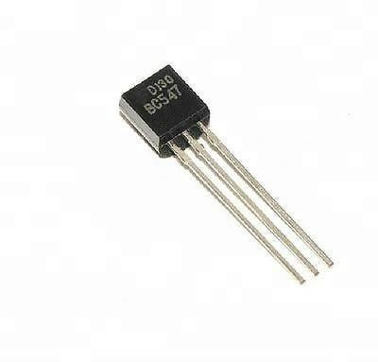

**Fig 4.5 BC547 TRANSISTOR**

The BC547 is a popular NPN bipolar junction transistor (BJT) commonly used in various electronic circuits. It is a low-power transistor with a maximum current rating of 100mA and a maximum voltage rating of 65V. The BC547

transistor has three pins: the collector (C), base (B), and emitter (E). The BC547 transistor is commonly used in amplifying, switching, and voltage regulation applications. It can be used as a switch to control small loads or as a driver for small-signal transistors, LEDs, and relays. The transistor's gain (hFE) typically ranges from 110 to 800, making it suitable for use in low-power audio amplifiers and preamplifiers. The BC547 transistor is housed in a small TO-92 package, making it easy to use and widely available.

The pin out for the transistor is as follows:

* + - Pin 1 (Collector): This pin is connected to the positive supply voltage.
    - Pin 2 (Base): This pin is used to control the transistor's operation.
    - Pin 3 (Emitter): This pin is connected to the ground.

When a small current is applied to the base pin, the transistor allows a larger current to flow from the collector to the emitter, effectively acting as a switch or amplifier. The base-emitter voltage (VBE) is typically around 0.6V, while the collector-emitter voltage (VCE) can range from 0 to 45V, depending on the load and operating conditions. In summary, the BC547 transistor is a versatile and widely used NPN BJT with a low power rating and a moderate gain. It is commonly used in amplifying, switching, and voltage regulation applications due to its small size, ease of use, and availability.

## RESISTOR

A resistor is a passive electrical component that is designed to limit the flow of current in a circuit. It is a type of fixed resistor, meaning that its resistance value is predetermined and cannot be adjusted. The resistance value of a resistor is measured in ohms (Ω), and the value of a 230 ohm resistor means that it will limit the flow of current in a circuit to 230 ohms.

## CHAPTER 5 WIRELESS POWER TRANSFER

## INDUCTIVE COUPLING

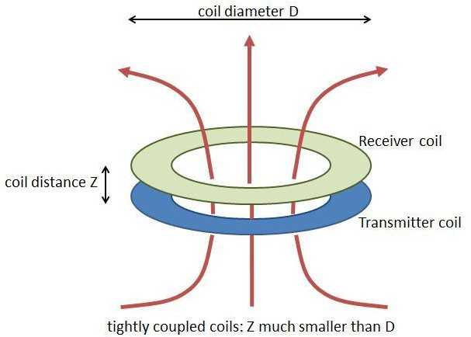

## Fig 5.1 Inductive Coupling

Inductive coupling is a technique that allows the transfer of electrical energy wirelessly between two circuits through a magnetic field. This method is widely used in many different applications, including wireless power transfer, transformers, and radio communications. Inductive coupling works by using two coils of wire, a primary and a secondary coil, which are arranged in proximity to each other. When an alternating current (AC) is passed through the primary coil, it generates a varying magnetic field around it. This magnetic field then induces an alternating current in the secondary coil, which can be used to power a device or charge a battery. The amount of energy transferred between the two coils is determined by several factors, including the number of turns in each coil, the frequency of the AC signal, and the distance between the coils. The efficiency of inductive coupling is also affected by factors such as the alignment of the two coils, the size of the coils,

and the material properties of the coils and surrounding environment. In wireless

power transfer applications, inductive coupling is used to charge portable devices such as smartphones and electric toothbrushes. In these applications, the primary coil is embedded in a charging pad or base station, while the secondary coil is embedded in the device to be charged. When the device is placed on the charging pad, the two coils are brought into proximity, and energy is transferred wirelessly from the pad to the device. In transformers, inductive coupling is used to step up or step down the voltage of an AC power signal. A transformer consists of two coils, the primary and the secondary coil, which are wrapped around a common magnetic core. When an AC current is passed through the primary coil, it generates a magnetic field around the core, which in turn induces a current in the secondary coil. Overall, inductive coupling is a versatile and useful technique that is widely used in many different applications. Its ability to transfer electrical energy wirelessly without the need for physical contact makes it a valuable tool in many different industries, from consumer electronics to industrial automation.

## INDUCTIVE CHARGING

Inductive charging, also known as wireless charging or contactless charging, is a method of transferring electrical energy from a power source to a device without the need for physical connectors or cables. The technique is based on the principle of electromagnetic induction, which allows electrical energy to be transferred wirelessly through a magnetic field. The process of inductive charging involves two components: a charging pad or base station, and a receiver coil embedded in the device being charged. The charging pad or base station contains a coil of wire that is energized with an alternating current (AC) signal, which creates a varying magnetic field around the coil. When the device being charged is placed on the charging pad, the receiver coil in the device's charging circuitry is positioned close to the charging pad's coil. As a result, the magnetic field generated by the charging pad induces a current in the receiver coil, which can be used to charge the device's battery.

The efficiency of inductive charging is affected by several factors, including

the distance between the charging pad and the device, the size and shape of the coils, and the frequency of the AC signal. The charging speed may also be affected by factors such as the capacity of the device's battery, the amount of power being supplied by the charging pad, and the quality of the charging circuitry. Inductive charging technology is available in several different standards, including Qi, Powermat and AirFuel. The Qi standard, developed by the Wireless Power Consortium, is currently the most widely used standard for inductive charging in smartphones and other portable electronics. Overall, inductive charging is a convenient and efficient method of charging electronic devices wirelessly, without the need for physical connections or cables. The technology has several advantages over traditional wired charging, including convenience, safety, and ease of use.

Inductive charging technology is constantly evolving, with newer and more advanced versions being developed all the time. Some of the latest developments in inductive charging include the ability to charge multiple devices at once, and the ability to charge devices from a greater distance. One of the challenges of inductive charging is that it can be less efficient than traditional wired charging, especially over longer distances. This is because the magnetic field generated by the charging pad weakens as it moves further away from the transmitter coil, which can reduce the amount of power that is transferred to the receiver coil.

## CHAPTER 6

**INDUCTANCE OF COIL AND COIL DESIGN**

## INTRODUCTION

Inductance is a property of an electrical circuit that determines the amount of energy stored in a magnetic field when a current flows through a conductor. A coil is an electrical component that is designed to create an electromagnetic field and store energy in the form of inductance. Coil design is essential for a wide range of electrical applications, from power generation and distribution to electronic devices. A well-designed coil can optimize the performance of electrical systems by controlling magnetic fields and minimizing energy losses. The inductance of a coil is determined by several factors, including the number of turns in the coil, the cross-sectional area of the coil, and the material used for the core. Designing a coil with the desired inductance requires careful consideration of these factors and selecting the appropriate materials and construction techniques. Coil design is critical in many industries, including power generation and distribution, telecommunications, and consumer electronics. For example, in power generation, coils are used in generators to convert mechanical energy into electrical energy, while in electronics, coils are used in various applications such as filters, transformers, and oscillators. Overall, inductance and coil design are fundamental concepts in electrical engineering, and understanding these principles is crucial for designing efficient and reliable electrical systems.

## SINGLE LAYER COIL

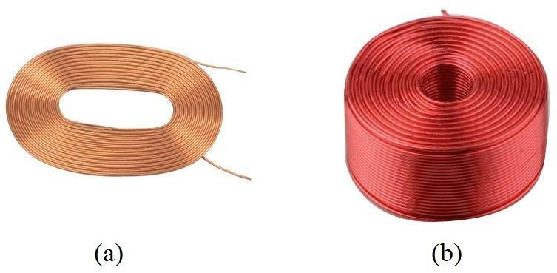

**Fig 6.1 Single Layer coil**

The wire used in a single-layer coil can be made of various materials, such as copper or aluminum, and can have different diameters or gauges depending on the application. The key characteristic of a single-layer coil is that the wire is wound in a single layer, with each turn adjacent to the previous turn. This configuration ensures that each turn of the wire is exposed to the same magnetic field, resulting in a consistent and predictable inductance.

Single-layer coils have several advantages over other types of coils, including:

* + - High-Quality Factor (Q-factor): Single-layer coils typically have a higher Q- factor than other types of coils, which is a measure of the efficiency of the coil. This means that single-layer coils can store energy more efficiently and with less loss than other types of coils.
    - Low Interwinding Capacitance: Single-layer coils have a lower interwinding capacitance than other types of coils, which can be beneficial in high- frequency applications where capacitance can cause unwanted effects.
    - Simple Design: Single-layer coils have a relatively simple design compared to other types of coils, which makes them easy to manufacture and less expensive. Single-layer coils are used in a wide range of applications, including filters, transformers, and inductors.

They are commonly used in radio-frequency (RF) circuits, where they are used to filter out unwanted frequencies or as part of an oscillator circuit. Overall, the single-layer coil is a simple but highly effective electrical component that is widely used in various applications. Understanding the characteristics and design considerations of single-layer coils is important for developing efficient and reliable electrical systems.

## LOSSES IN COIL

In electrical circuits, losses in coils are caused by various factors, including resistance, hysteresis, and eddy currents. These losses can result in a decrease in the efficiency of the coil and can cause heating, which can lead to failure if not properly managed. Resistance Losses: Resistance losses are caused by the resistance of the wire used to make the coil. When current flows through the wire, some energy is converted into heat due to the resistance of the wire. These losses can be reduced by using wire with a lower resistance or by increasing the cross- sectional area of the wire. Hysteresis Losses: Hysteresis losses are caused by the reversal of the magnetic field in the core of the coil. When the magnetic field in the core changes direction, the magnetic domains in the core can become misaligned, resulting in energy loss due to friction between the domains. These losses can be reduced by using a core made of a material with a low coercivity, such as soft iron.

Eddy Current Losses: Eddy current losses are caused by currents that flow in the core of the coil due to changes in the magnetic field. These currents can cause energy loss due to resistance in the core material. Eddy current losses can be reduced by using a core made of a material with a high resistivity or by using laminated core materials that reduce the flow of eddy currents.

Dielectric Losses: Dielectric losses are caused by energy loss in the insulation material used to insulate the wire in the coil. These losses can be reduced by using high-quality insulation materials with low dielectric loss.

Radiative Losses: Radiative losses are caused by energy loss due to electromagnetic radiation from the coil. These losses can be reduced by using shielding or by placing the coil in a metal enclosure. Overall, minimizing losses in a coil is essential for improving its efficiency and reliability. Understanding the different types of losses that can occur in a coil and how to minimize them is critical for developing high-performance electrical systems.

## SKIN EFFECT

Skin effect is a phenomenon that occurs in a coil or any other conductor carrying an alternating current. The skin effect is caused by the tendency of alternating current to flow primarily on the surface of the conductor, rather than through its entire cross-section. This is due to the self-induced magnetic field generated by the alternating current, which causes the current to be concentrated near the surface of the conductor.

The skin effect can be reduced by using a coil made of a material with a high electrical conductivity, such as copper or aluminum. Additionally, using a coil with a larger cross-sectional area can help reduce the skin effect. Another way to reduce the skin effect is to use a multistrand wire instead of a solid wire, as the multiple strands provide a larger effective cross-sectional area for the flow of current. In summary, the skin effect is a phenomenon that affects the flow of current in a coil carrying an alternating current. the causes and effects of the skin effect, it is possible to design coils that are more efficient and have reduced power loss.

## PARASITIC CAPACITANCE

Parasitic capacitance is a type of unwanted capacitance that exists between two conductive surfaces or between a conductive surface and a non-conductive surface. In a coil, parasitic capacitance is the capacitance that exists between the turns of the coil or between the coil and its surroundings. The parasitic capacitance of a coil can have a significant impact on the performance of the coil. It can cause signal loss, interference, and reduced efficiency. The capacitance can also affect the resonant frequency of the coil and can lead to tuning problems. There are several factors that can contribute to the parasitic capacitance of a coil. One factor is the physical size and shape of the coil.

A larger coil will generally have a higher capacitance than a smaller coil.

Additionally, the spacing between the turns of the coil can also affect the parasitic capacitance. The closer the turns are together, the higher the capacitance will be.

Parasitic capacitance can be reduced by using techniques such as shielding, isolation, and minimizing the physical size and spacing of the coil. One approach to reducing parasitic capacitance is to use a multilayer coil design, which involves stacking multiple coils on top of each other with insulation in between. This design increases the effective distance between the turns of the coil, which reduces the capacitance. In summary, parasitic capacitance is an unwanted capacitance that can exist in a coil. It can have a significant impact on the performance of the coil, including signal loss, interference, and reduced efficiency. By understanding the factors that contribute to parasitic capacitance and using appropriate design techniques, it is possible to minimize its effects and improve the performance of the coil.

## CHAPTER 7 RESULTS AND DISCUSSION

## 7.1 HARDWARE SETUP

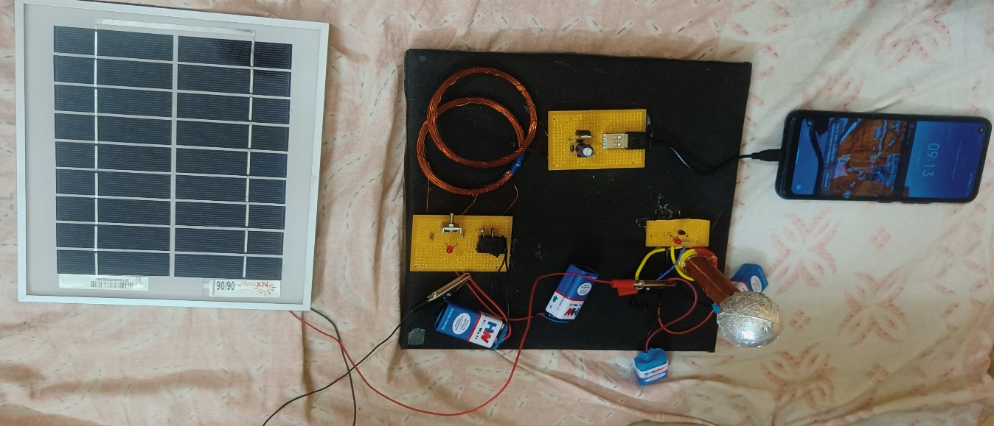

## Fig7.1 Hardware setup

To assemble a wireless power transmission system, first, gather all the necessary components as listed: an IRF540N MOSFET, an IN4007 diode, a 1000uF 16V capacitor, an LM7805 voltage regulator, a USB port, a 9V battery, and any required wires or a breadboard. Begin by correctly aligning the pins of the MOSFET and connecting it to the breadboard. Connect the drain pin of the MOSFET to the positive terminal of the capacitor, and the source pin to the negative terminal of the capacitor. Next, connect the anode of the IN4007 diode to the positive terminal of the capacitor and the cathode to the output pin of the LM7805 voltage regulator. Ensure that the input pin of the LM7805 is connected to the positive terminal of the 9V battery. Connect the USB port to the output pin of the LM7805, taking care to correctly connect the data and power pins. The USB port will be able to provide power to any devices requiring wireless charging.

Finally, connect the gate pin of the MOSFET to a separate circuit that generates a high-frequency alternating current (AC) signal. This can be a separate breadboard circuit or an existing device, such as a mobile phone, that generates an AC signal. Once the circuit is fully connected, turn on the device generating the AC signal. This will cause the MOSFET to switch on and off rapidly, generating a high- frequency magnetic field that can transmit power wirelessly to any devices placed within range of the field. Note that this is a basic setup, and there are many additional components and modifications that can be made to improve the efficiency and range of the wireless power transmission system. It is essential to take necessary safety precautions when working with high voltage, as it can be hazardous.

## CHAPTER 8 CONCLUSION AND FUTURE SCOPE

## CONCLUSION

In conclusion, the hardware setup using the IRF540N MOSFET, IN4007 diode, 1000uF 16V capacitor, LM7805 voltage regulator, USB port, and 9V battery can be used to create a basic wireless power transmission system. This setup generates a high-frequency magnetic field that can be used to transmit power wirelessly to any devices placed within range of the field. However, it is important to note that this is just a basic setup, and there are many additional components and modifications that can be made to improve the efficiency and range of the wireless power transmission system. Safety precautions must also be taken when working with high voltage to prevent any accidents. Overall, this project can be a great way to learn about electronics and explore the possibilities of wireless power transmission.

## FUTURE SCOPE

Wireless power transmission technology has the potential to revolutionize the way electric vehicles (EVs) are charged. Instead of having to physically plug in a charging cable, wireless power transfer technology can enable the charging of an EV simply by parking it over a charging pad, similar to how wireless charging works for smartphones. Here are some potential future scopes for wireless power transmission for EV vehicles: Increased Convenience: With wireless charging, drivers would no longer need to plug in their EVs to a charging station, which would make it easier and more convenient to charge their vehicles. This could increase the adoption of electric vehicles, especially among those who live in urban areas and do not have a garage to plug in their car. Efficiency: Wireless power transfer technology can be designed to be more efficient than traditional wired charging systems, resulting in less energy loss

and potentially faster charging times. This would help to reduce charging times and improve the overall efficiency of the charging process. Flexibility: With wireless charging, charging pads can be installed in various locations, such as at home, in parking garages, or even on the streets. This would provide more flexibility and convenience for drivers, as they could charge their EVs at more locations without having to find a charging station. Autonomous Charging: Autonomous charging can be enabled through wireless power transfer technology, which would allow EVs to charge themselves without any human intervention. This would be particularly useful for fleet vehicles, such as taxis or delivery trucks,that need to be on the road as much as possible. Increased Range: Wireless power transfer technology can be used to charge EVs while they are in motion, which would increase the range of the vehicle. This technology is still in its early stages, but if it becomes practical, it could make EVs a more viable option for long-distance travel. In conclusion, the potential future scopes for wireless power transmission for EV vehicles are numerous and exciting. As the technology continues to develop, it has the potential to revolutionize the way we think about charging our vehicles, making EVs more convenient and accessible for everyone.

## REFERENCES

1. M.Bertoluzzo, K.N.Mude and G.Buja, “Preliminary investigation on contactless energy transfer for electric vehicle battery recharging”, Proceedings of IEEE International Conference on Industrial and Information Systems (ICIIS), 2012.
2. K.N.Mude, M.Bertoluzzo and G.Buja, “Design of contactless battery charger for electrical vehicle”, Proceedings of IEEE International Conference of AFRICON 2013, 2013.
3. M.Bertoluzzo, and G.Buja and K.N.Mude, “Characteristic Evaluation of Wireless Battery Chargers for Electric Vehicles”, Proceedings of 10th Jubilee International Symposium on Advanced Electromechanical Motion Systems, 21-22 October 2013.
4. K.N.Mude, H.Dashora, M.Bertoluzzo, and G.Buja, “From Wired to In- moving Battery Chargers for Electric Vehicle”, Proc.of DEEE’14, 2014.
5. Moon J, Hwang H, Jo B, Kwon C-K, Kim T-G, Kim S-W. Design and Implementation of a high-efficiency 6.78MHz resonant wireless power transfer system with a 5W fully integrated power receiver. IET Power Electron, 2017.
6. Yengi Y., Khan S. A., and Kucuk K., Design and performance analysis of information centric network for Internet of Things, 25th Signal Processing and Communications Applications Conference (SIU), Antalya, 2017.
7. Trevisan R, Costanzo A. A UHF Near-Field Link for Passive Sensing in Industrial Wireless Power Transfer Systems, IEEE Trans Microw Theory Tech, 2016.
8. Sugino M, Masamura T. The wireless power transfer systems using the Class E push-pull inverter for industrial robots. In: IEEE Wireless Power Transfer Conference (WPTC), Taipei, Taiwan; 2017.
9. Li S, Mi CC. Wireless power transfer for electric vehicle applications. Journal Emerg Sel Top Power Electron 2015.
10. Nassim I, Basa Arsoy A, & Cakur B, Load Profile-Based Power Loss Estimation for Distribution Networks. Electrica, 2018.